International Alliance of Theatrical Stage Employees, Motion Picture Technicians, Artists and Allied Crafts of the United States and Canada. AFL-CIO, CLC

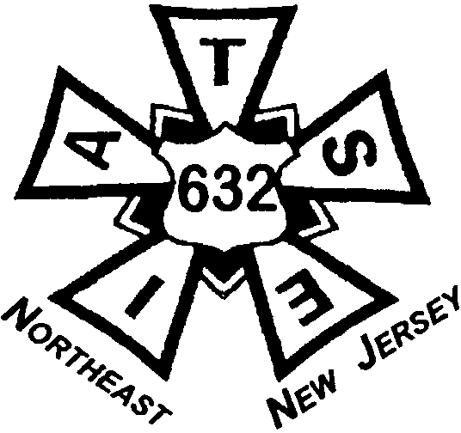

LOCAL 632 I.A.T.S.E.
Serving the Meadowlands and Northern New Jersey
300-1 Route 17 South, Suite 6, Lodi, NJ 07644
Office: (201) 262-4182 Fax: (201) 262-4138
Email: iatse.sixthreetwo@verizon.net

CHECK-OFF AUTHORIZATION FOR EMPLOYER TO DEDUCT
4% UNION PER CAPITA TAX

I hereby authorize my employer, to deduct from my wages the sum of four percent (4%) of my total earned gross salary each pay period for Per Capita Tax. These dues are in accordance with the Constitution and By-Laws of Local 632 IATSE, as well as the Collective Bargaining Agreement between Local 632 IATSE and my Employer. In the event that Local 632 IATSE constitutionally changes their dues structure, Local 632 IATSE will duly notify my Employer.

This authorization shall become effective immediately and shall remain in effect irrevocably until the termination of the Collective Bargaining Agreement between Local 632 IATSE and my Employer. This authorization shall automatically renew itself from year to year, unless a written notice of revocation is filed within ten (10) days prior to any annual expiration date of the current contract referred to above or any succeeding contracts.

I hereby assign the sums deducted, according to the above, to Local 632 IATSE of the AFL-CIO and authorize you to forward such sums to the Financial Secretary of Local 632 IATSE in a timely manner at the following address:

Local 632 IATSE
300-1 Route 17 S., Suite 6
Lodi, NJ 07644

Print Name: ______________________________________________________________

Address: ________________________________________________________________

Social Security Number: ____________________________________________________

Date: __________________

Signature: _______________________________________________________________

