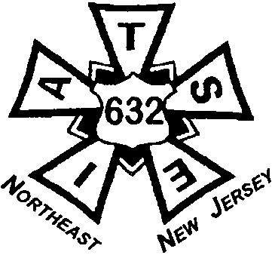*International Alliance of Theatrical Stage Employees, Motion Picture Technicians, Artists and Allied Crafts of the United States and Canada. AFL-CIO, CLC*

LOCAL 632 I.A.T.S.E.

*Serving the Meadowlands and Northern New Jersey*

300-1 Route 17 South, Suite 6, Lodi, NJ 07644

Office: (201) 262-4182 Fax: (201) 262-4138

Email: [iatse.sixthreetwo@verizon.net](mailto:iatse.sixthreetwo@verizon.net)

**INFORMATION STATUS SHEET**

SSN: ________________________________________________________

NAME: ________________________________________________________

ADDRESS: ________________________________________________________

CITY: ________________________________________________________

STATE: _______________ ZIP: _________________________________

HOME #: _______________________________________________________

CELL #: _______________________________________________________

EMAIL: _______________________________________________________

BIRTHDATE: _______________________________________________________

***In Case of Emergency, please notify:***

Name: _______________________________________________________

Phone #: _______________________________________________________